Asymmetric DCC correlation: EURUSD and USDJPY
Method 10 / GARCH(1,1) + Cappiello-Engle-Sheppard ADCC / Alpari D1 full available history

Study setup
Logical pair: EURUSD , USDJPY
Broker symbols: EURUSD_i , USDJPY_i
Snapshot: 2026-11-03_majors_alpari_D1
Timeframe: D1
Matched return window: 1999-01-05 to 2026-11-02 (UTC bar dates)
Matched return count n: 7200
Dropped unfinished last bar dated 2026-11-03 UTC after a tick-volume check against the prior complete day.
EURUSD GARCH(1,1): mu=0.000006, omega=0.001153, alpha=0.036771, beta=0.959944
USDJPY GARCH(1,1): mu=0.000113, omega=0.005008, alpha=0.052022, beta=0.935301
ADCC: a=0.056516, b=0.896400, g=0.035173, a+b+g/2=0.970502
Nested DCC (g=0): a=0.048271, b=0.930831
Negative shock: n = min(z, 0) in broker quote direction (not inverted)
Burn-in ignored in path summaries and chart: first 60 updates
Complete matched rows (Excel): EURUSD-USDJPY_ADCC_D1.xlsx
Complete matched rows (HTML table): EURUSD-USDJPY_ADCC_D1_data.html

Method carried forward
Asymmetric DCC extends Engle DCC with an extra term on joint negative standardised shocks. Each matched daily log return of close, ln(close_t / close_t-1), is first filtered by a constant-mean GARCH(1,1). Then z = residual / sigma and n = min(z, 0). The Cappiello-Engle-Sheppard recursion uses A = (1-a-b) Q_bar - g N_bar with N_bar = mean(n n'). Quotes are not inverted, so a negative shock is a negative log return in the broker quote. Nested symmetric DCC (g = 0) is fit on the same z path for comparison. Constraints: a,b,g >= 0 and a + b + g/2 < 1. Path summaries ignore the first 60 updates. The headline is latest ADCC rho. Pearson r is a side check only. This is not a cause, lead, or trading signal.

Results
Latest ADCC rho: -0.390918
Latest nested DCC rho: -0.373270
Post-burn-in ADCC path (n=7140): mean=-0.378665, median=-0.424298, min=-0.711175, max=0.614588, std=0.200483
Share of post-burn-in days with |rho| >= 0.4: 55.92%; |rho| >= 0.7: 0.03%
Same-sample Pearson r: -0.300952
ADCC minus r: -0.089966
ADCC minus nested DCC: -0.017649

Conclusion
Over 7200 matched daily log-return rows for EURUSD and USDJPY (broker quote directions unchanged), latest ADCC rho is -0.3909 (negative, weak conditional linear link in this sample) with fitted a=0.0565, b=0.8964, g=0.0352. Nested symmetric DCC latest rho is -0.3733 (ADCC minus DCC = -0.0176). After a 60-day burn-in, path mean is -0.3787 and std is 0.2005. Same-sample Pearson r is -0.3010 (ADCC minus r = -0.0900). This does not establish cause, lead-lag, or a lasting trading rule.

Charts
Daily closes

Daily log returns
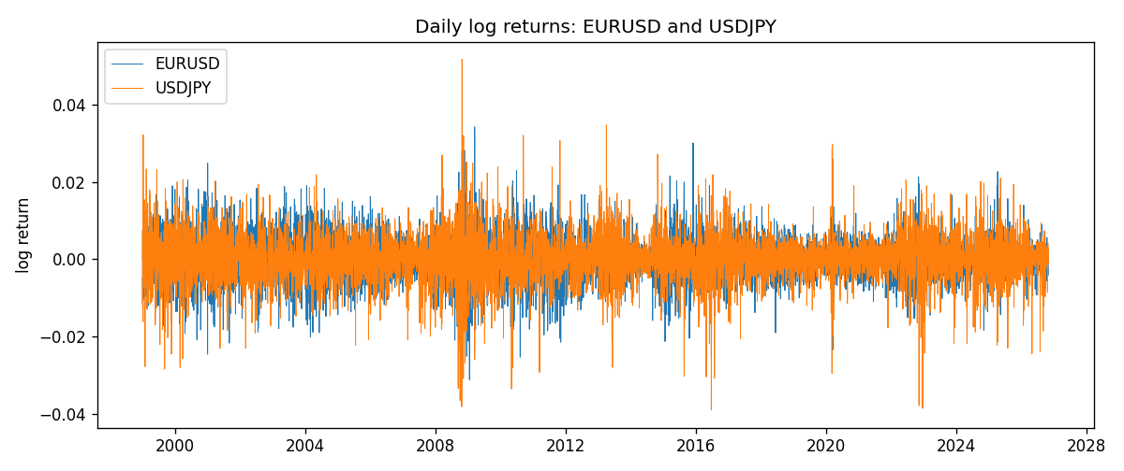
ADCC rho path with nested DCC and Pearson r
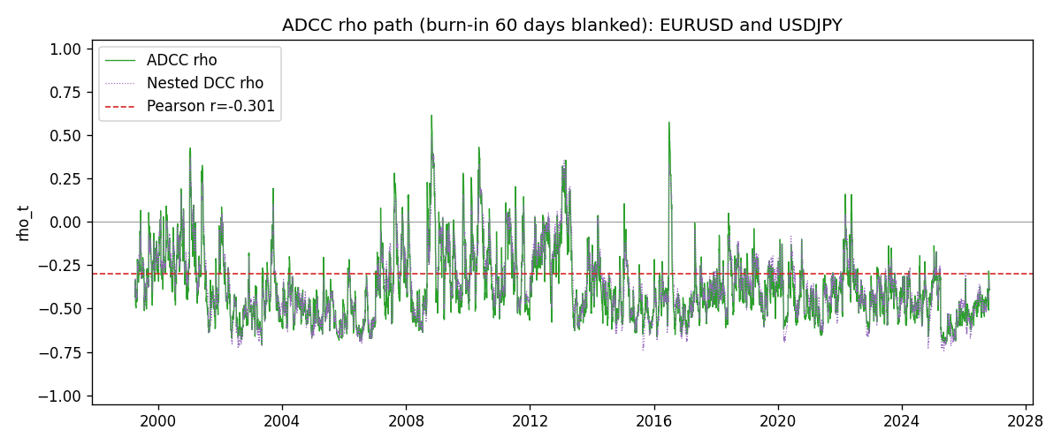

Data report
Every matched row that entered the ADCC recursion is stored in the sibling Excel workbook named EURUSD-USDJPY_ADCC_D1.xlsx. Embedding all rows as a Word table is impractical at this length; the Word file holds the column list, column summaries, and the first and last 15 matched rows.
Columns: time, EURUSD_open, USDJPY_open, EURUSD_high, USDJPY_high, EURUSD_low, USDJPY_low, EURUSD_close, USDJPY_close, EURUSD_tick_volume, USDJPY_tick_volume, EURUSD_spread, USDJPY_spread, EURUSD_real_volume, USDJPY_real_volume, EURUSD_log_return, USDJPY_log_return, EURUSD_sigma, USDJPY_sigma, EURUSD_z, USDJPY_z, EURUSD_n, USDJPY_n, q11, q22, q12, rho_adcc, rho_dcc
Column summaries (matched calculation rows)
column | count | mean | std | min | 25% | 50% | 75% | max
EURUSD_open | 7200 | 1.1812699 | 0.15089907 | 0.8272 | 1.086045 | 1.16609 | 1.2939325 | 1.5995
USDJPY_open | 7200 | 113.80877 | 19.206548 | 75.693 | 104.4225 | 110.983 | 120.69125 | 163.824
EURUSD_high | 7200 | 1.1864006 | 0.15149686 | 0.8326 | 1.0901575 | 1.17121 | 1.2991625 | 1.6038
USDJPY_high | 7200 | 114.3063 | 19.268128 | 76.001 | 104.878 | 111.441 | 121.26 | 163.978
EURUSD_low | 7200 | 1.1762568 | 0.15022122 | 0.8227 | 1.0819775 | 1.162475 | 1.288265 | 1.5865
USDJPY_low | 7200 | 113.28572 | 19.134551 | 75.402 | 103.8875 | 110.53 | 120.17 | 163.628
EURUSD_close | 7200 | 1.1813075 | 0.15087411 | 0.8267 | 1.085995 | 1.16602 | 1.2939425 | 1.5997
USDJPY_close | 7200 | 113.82186 | 19.221964 | 75.811 | 104.4165 | 111.023 | 120.6855 | 163.851
EURUSD_tick_volume | 7200 | 103020.56 | 173417.03 | 218 | 9398.5 | 52714 | 99443.25 | 1471626
USDJPY_tick_volume | 7200 | 106139.77 | 179306.98 | 149 | 9927.5 | 53095 | 92761 | 1803508
EURUSD_spread | 7200 | 19.389444 | 16.57873 | 0 | 8 | 12 | 30 | 50
USDJPY_spread | 7200 | 20.3175 | 17.636173 | 0 | 6 | 11 | 30 | 50
EURUSD_real_volume | 7200 | 4.0252061e+10 | 1.6676396e+11 | 0 | 0 | 0 | 0 | 3.6149665e+12
USDJPY_real_volume | 7200 | 3.4708591e+10 | 1.6077621e+11 | 0 | 0 | 0 | 0 | 3.8834203e+12
EURUSD_log_return | 7200 | -1.012e-05 | 0.00580063 | -0.03123819 | -0.0032472 | 0 | 0.00325137 | 0.03433183
USDJPY_log_return | 7200 | 4.989e-05 | 0.00620383 | -0.03908203 | -0.00319719 | 0.00011638 | 0.00340925 | 0.05184024
EURUSD_sigma | 7200 | 0.00556697 | 0.00169853 | 0.00257921 | 0.00432257 | 0.00538963 | 0.00649694 | 0.01459445
USDJPY_sigma | 7200 | 0.00599078 | 0.00174037 | 0.00337195 | 0.00477706 | 0.00569213 | 0.00679079 | 0.0188299
EURUSD_z | 7200 | -0.00306844 | 1.0000302 | -5.7814238 | -0.61983469 | -0.00096284 | 0.60822171 | 5.207937
USDJPY_z | 7200 | -0.00915608 | 1.0002787 | -6.5322391 | -0.56387758 | 0.00045357 | 0.58084601 | 7.1025818
EURUSD_n | 7200 | -0.38689826 | 0.5931898 | -5.7814238 | -0.61983469 | -0.00096284 | 0 | 0
USDJPY_n | 7200 | -0.37444637 | 0.62365698 | -6.5322391 | -0.56387758 | 0 | 0 | 0
q11 | 7200 | 1.0002739 | 0.30491053 | 0.47503523 | 0.79757351 | 0.93930665 | 1.1236724 | 3.8460262
q22 | 7200 | 1.0008086 | 0.41163053 | 0.39519677 | 0.74933219 | 0.90222455 | 1.128442 | 4.600046
q12 | 7200 | -0.36011485 | 0.24937355 | -1.9138739 | -0.48869215 | -0.3634546 | -0.24659345 | 1.7976089
rho_adcc | 7200 | -0.37818911 | 0.20010545 | -0.71117511 | -0.51973827 | -0.42334667 | -0.28236151 | 0.61458807
rho_dcc | 7200 | -0.36555628 | 0.19984513 | -0.74369858 | -0.50526546 | -0.40285862 | -0.25816589 | 0.48333395
First 15 matched rows (selected columns)
time | EURUSD_log_return | USDJPY_log_return | EURUSD_z | USDJPY_z | EURUSD_n | USDJPY_n | q11 | q22 | q12 | rho_adcc | rho_dcc
1999-01-05 | -0.0048360507 | -0.00017868311 | -0.73616708 | -0.026016173 | -0.73616708 | -0.026016173 | 1 | 1 | -0.35994213 | -0.35994213 | -0.35994213
1999-01-06 | -0.011547966 | 0.0075660159 | -1.7722394 | 0.68489419 | -1.7722394 | 0 | 0.97553425 | 0.92493604 | -0.34086763 | -0.35884644 | -0.35413061
1999-01-07 | 0.0076280636 | -0.012851583 | 1.1260523 | -1.2135685 | 0 | -1.2135685 | 1.1918918 | 0.88409721 | -0.39412433 | -0.38394129 | -0.38290318
1999-01-08 | -0.010902799 | -0.0047719894 | -1.6042187 | -0.45360758 | -1.6042187 | -0.45360758 | 1.1695182 | 0.95601296 | -0.4504962 | -0.42604526 | -0.4220051
1999-01-11 | -0.007103287 | -0.016195423 | -1.0168411 | -1.5533434 | -1.0168411 | -1.5533434 | 1.3137628 | 0.90430983 | -0.35707585 | -0.32759962 | -0.36136309
1999-01-12 | 0.0045103728 | 0.032310364 | 0.64424084 | 2.9710485 | 0 | 0 | 1.3019042 | 1.0603305 | -0.19523187 | -0.16616539 | -0.26078959
1999-01-13 | 0.010845346 | 0.0081373171 | 1.5679199 | 0.62604799 | 0 | 0 | 1.2199281 | 1.4778292 | -0.08680156 | -0.064646988 | -0.14152788
1999-01-14 | 0 | 0 | -0.00079467369 | -0.0090371004 | -0.00079467369 | -0.0090371004 | 1.2619255 | 1.3753508 | -0.04230462 | -0.032111766 | -0.098794996
1999-01-15 | -0.010153245 | 0.0055343401 | -1.459983 | 0.44589395 | -1.459983 | 0 | 1.1606345 | 1.261346 | -0.057892716 | -0.04784748 | -0.10341997
1999-01-18 | 0.0036256946 | 8.7600193e-05 | 0.50998026 | -0.0021793607 | 0 | -0.0021793607 | 1.265276 | 1.1703812 | -0.10865839 | -0.089290853 | -0.12959834
1999-01-19 | -0.00017235436 | -0.0056219403 | -0.025436021 | -0.49977476 | -0.025436021 | -0.49977476 | 1.1783365 | 1.0776041 | -0.11743572 | -0.10421636 | -0.1332028
1999-01-20 | -0.0031939256 | -0.0053879917 | -0.46610153 | -0.49130026 | -0.46610153 | -0.49130026 | 1.0857645 | 1.0173398 | -0.12407532 | -0.11805505 | -0.13630832
1999-01-21 | 0.0030215416 | 0.0084664056 | 0.44600181 | 0.76459414 | 0 | 0 | 1.0226431 | 0.96254882 | -0.11019634 | -0.11106922 | -0.12864477
1999-01-22 | -0.0012075213 | 0.0060412564 | -0.18217961 | 0.55095993 | -0.18217961 | 0 | 0.95738362 | 0.92434229 | -0.099478938 | -0.1057479 | -0.11457412
1999-01-25 | -0.0030251979 | -0.0073594164 | -0.46361664 | -0.71057715 | -0.46361664 | -0.71057715 | 0.89068611 | 0.87421025 | -0.11481717 | -0.13011775 | -0.12403377
Last 15 matched rows (selected columns)
time | EURUSD_log_return | USDJPY_log_return | EURUSD_z | USDJPY_z | EURUSD_n | USDJPY_n | q11 | q22 | q12 | rho_adcc | rho_dcc
2026-10-13 | 0.0037402957 | -0.0018932826 | 1.0814987 | -0.41189531 | 0 | -0.41189531 | 1.1781014 | 0.58007443 | -0.35298998 | -0.42700129 | -0.42609235
2026-10-14 | -0.0037582255 | 7.5800166e-05 | -1.0831397 | -0.0078579763 | -1.0831397 | -0.0078579763 | 1.1515979 | 0.56400833 | -0.36156766 | -0.44863835 | -0.43533605
2026-10-15 | 0.0056053107 | -0.0018524319 | 1.6013525 | -0.41980372 | 0 | -0.41980372 | 1.169305 | 0.53405666 | -0.34330041 | -0.43442694 | -0.42049641
2026-10-16 | 0.0017724895 | -0.00037976126 | 0.48991533 | -0.1070814 | 0 | -0.1070814 | 1.2225353 | 0.52336108 | -0.36569919 | -0.45718565 | -0.42996678
2026-10-19 | -0.0025394633 | 0.0034946841 | -0.71373462 | 0.7494982 | -0.71373462 | 0 | 1.1388898 | 0.49866614 | -0.35074919 | -0.46542625 | -0.42836418
2026-10-20 | 0.0023881672 | -0.0022546642 | 0.67227597 | -0.52778732 | 0 | -0.52778732 | 1.0970529 | 0.50722604 | -0.364616 | -0.4887887 | -0.4439401
2026-10-21 | -0.00032046717 | -0.00032883504 | -0.092679355 | -0.099838735 | -0.092679355 | -0.099838735 | 1.0383853 | 0.50869208 | -0.3668663 | -0.50477875 | -0.45344534
2026-10-22 | -0.0015949606 | -0.0085942669 | -0.46197452 | -2.0049221 | -0.46197452 | -2.0049221 | 0.96104051 | 0.48537944 | -0.3479821 | -0.50950139 | -0.44967551
2026-10-23 | -0.001338521 | 0.00035080446 | -0.39241905 | 0.050511561 | -0.39241905 | 0 | 0.91048927 | 0.83212991 | -0.24697861 | -0.28374379 | -0.33197584
2026-10-26 | -0.0022706559 | 0.0041238746 | -0.67286564 | 0.87178707 | -0.67286564 | 0 | 0.85972629 | 0.77453941 | -0.24248341 | -0.29715303 | -0.33241822
2026-10-27 | -0.004152342 | 0.0027651658 | -1.2373614 | 0.57686509 | -1.2373614 | 0 | 0.84161482 | 0.76572404 | -0.27048575 | -0.33693922 | -0.35595064
2026-10-28 | 0.0022262927 | -0.00095679538 | 0.65226651 | -0.23562105 | 0 | -0.23562105 | 0.92424891 | 0.73367604 | -0.30277563 | -0.36768361 | -0.3797
2026-10-29 | 0.0022571351 | -0.00038043789 | 0.66615996 | -0.11082772 | 0 | -0.11082772 | 0.88198592 | 0.69123145 | -0.30006545 | -0.38430268 | -0.38335207
2026-10-30 | -0.0011458446 | -0.0010596481 | -0.34304139 | -0.26851924 | -0.34304139 | -0.26851924 | 0.8451366 | 0.64922001 | -0.29312273 | -0.39572191 | -0.38233128
2026-11-02 | 0.002120569 | 0.0026438521 | 0.63825371 | 0.58955131 | 0 | 0 | 0.79781445 | 0.61704575 | -0.27428102 | -0.39091842 | -0.37326985

